Champion Annotator – Project Plan

Thomas Dil, Benjamin Kulbago, Timothy McDaniel, Daniel Schnipke

30 January 2017

GitHub Repo: <https://github.com/schnip/champAnn/>

Project Work:

We have begun work on our project in three important areas. We have collected some data, written a script to identify champion locations based on health bars, and have a script that will allow us to identify a depicted champion by selecting a name from a drop down box.

We have gathered an initial amount of data to work with. We have taken in-game screenshots and have taken full screen windows-snip screenshots from a YouTube highlights video. The in-game screenshots have covered many of the champions early in the alphabet (A-E). We do not have data on every champion in that range because nobody in our project group has put work into obtaining each champion. Between the three of us who play the game, we cover most of the game’s playable characters. We took screenshots with the champion facing up, down, right, left, and all four diagonals. We also grabbed images of the champions moving in a variety of directions, because many characters have a different appearance while in motion.

In order to locate champions on screen, we have chosen to first identify an object that every champion, big or small, good or ugly, has in common; a health bar. We have written a script to identify allied health bars (blue and black), player health bars (green and black), and enemy health bars (red and black). If a player has colorblind mode enabled, then the health bar will be yellow. We have not added colorblind mode compatibility to our project. This script returns the coordinates of a bounding box below the health bar that will contain the general area where a champion is.

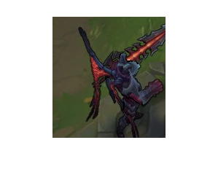

a picture of the bounding box below a champion’s health bar. The depicted champion is recognizable as Aatrox, a member of League’s Bruiser-class of champions.

Goals:

Minimum goals:

* Be able to find and classify champions that are at rest and have limited special effects around them.

Reasonable goals:

* Find and classify champions that are moving on a variety of backgrounds. Champions may be standing in water or on different parts of the map
* Find and classify champions in frames of video. This may not be live.
* Find and classify champions through light particle effects (glowing effects of health potions or some champion abilities activated)

Stretch:

* Will read and classify champions frame-by-frame from an input YouTube link
* Find and classify champions through heavy special effects and through each champion casting abilities.

Timeline:

End of 8th week: classifier for n different champions.

Middle of 9th week: classifier for most of League’s champions, classifier handles some particle effects.

Beginning of 10th week: classifier will analyze a video frame by frame